

David Toews, Travis Vanos

Group 3

GISC9314-D2

Compass Traverse Survey

Group 3



Mr. Xinxia Jiang

Professor – GISC9301 October 22, 2015  
Niagara College GISC9314-D2   
135 Taylor Road  
Niagara-on-the-lake, ON  
L0S 1J0

Dear Mr. Xinxia Jiang   
  
Please accept this letter as our formal submission of Assignment two: GISC9314-D2 Pace and Compass Traverse Survey – Group 3 for Travis Vanos and David Toews. The works were completed with Travis Vanos as the Party chief/Pacer, David Toews as Pacer/Compass Observer and Barbara Tomczyk as Pacer/Reader. The purpose of this assignment is to successfully gain the required skills to preform, map and calculate corrections for a completed Compass Traverse Survey. The following sections will be fulfilling the deliverables as outlined in the GISC9314-D2 requirements. The following procedures will be covered including, but not limited to:

* Practicing the proper surveying principles and field not booking standards
* Preforming a controlled loop traverse survey, and plotting map from raw data
* Correcting the raw data and plotting a final map

Following the according steps please find the required material sent electronically and in physical form. Should you have any questions regarding the enclosed documents, or if there are technical issues regarding the files please contact Travis Vanos or David Toews at your convenience at [travis.vanos@gmail.com](mailto:travis.vanos@gmail.com) or david.toews@gmail.com. We eagerly await your comments and suggestions.  
  
Sincerely,

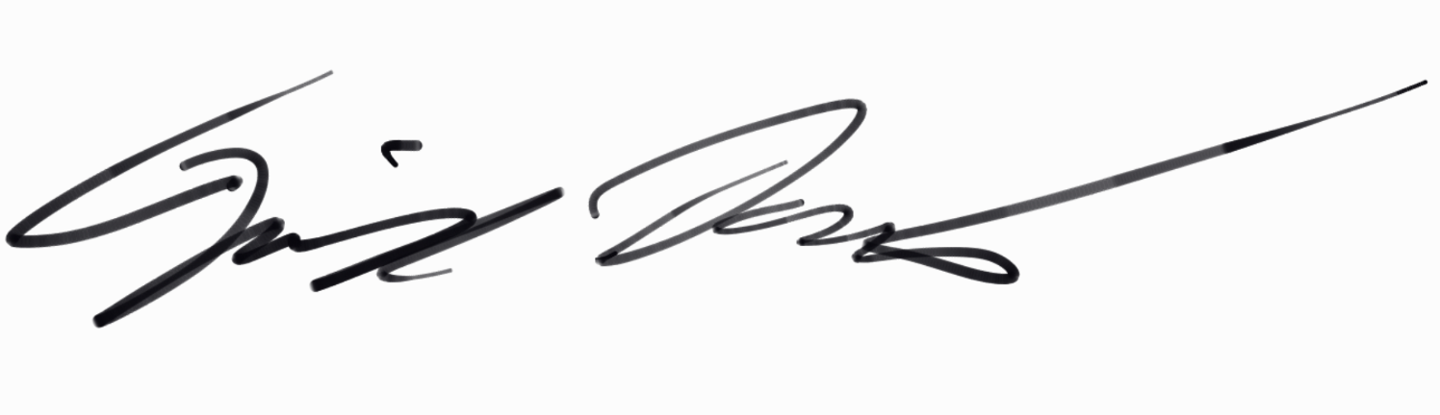

Travis Vanos   
 Party Chief - GIS/GM Candidate, Niagara College  
 T. V

Enclosures: VANOS-GISC9301-D1

Executive Summary

**The purpose of this assignment is to successfully gain the required skills to preform, and map a Compass Traverse Survey. The works encompasses the data collected using proper surveying methods discussed in class and following the Compass Traverse Survey procedures as outlined in the GISC9314-D2 deliverables. The following procedures will be covered including, but not limited to:**

* **Practicing the proper surveying principles and field not booking standards**
* **Preforming a controlled loop traverse survey, and plotting map from raw data**
* **Correcting the raw data and plotting a final map**

**The outcome will be a foundation of skills needed to perform a Compass Traverse Survey and build upon skills such as team working, preparing and planning, decision-making, measuring angles and distances of traverses, establishing control points, performing checks for accuracy, recording field notes, and reducing errors in measurements.**

Table of Contents

Contents

Executive Summary ii

Chapter 3 1

a. What type of feature does the ‘Cities’ layer Contain? 1

b. What country is Quito in? 2

c. What is one procedure to make the city labels available when the scale is larger than a given ratio? 3

d. What type of feature is contained in the ‘Countries’ layer? 4

e. How many records are contained, in total, in the table ‘Attributes of Cities > 1 Million’? 4

f. How many fields are there in the table ‘Attributes of Cities> 1 Milliion’? 5

g. Describe (in no more than one paragraph) how you could determine the mean precipitation (cont.) 5

Chapter 4 …………………………………..6

a. What type of file (what type of data) is the file World.mdb ………………………………………………………………….6

b. What is the countries component of World.mdb known as (generically)? 6

c. What type of file (what type of data) is the file ex04c.mxd? 7

d. What coordinate system is used for the ‘countries’ personal geodatabase (hint: properties)? 7

e. What sorts of AutoCAD file types can ArcCatalog ‘recognize’? 8

f. What type of file is US_Cities_PM? 8

g. What do you suppose ArcMap and/or ArcCatalog would do if you attempted (cont.) 8

Chapter 7 9

a. At a scale of 1:1,000,000 what would be the most appropriate symbol (cont.) 9

b. At a scale of 1:200 what would be the most appropriate symbol to represent (cont.) 9

c. You are given a map of the Niagara Region that is divided into 12 distinct areas (cont.). 9

d. You are retained by Niagara College’s Landscape Design team to assist with the visualization of new facilities to be constructed at the Glendale Campus in Niagara-On-The-Lake. (cont.) 10

Figure One: . 11

Figure Two: 11

# Introduction

The members of Equilibrium Consulting ltd. surveying team have completed a Compass traverse Survey (CTS) and consolidated the results in this report. Following proper surveying principles and field not booking, data has been collected and corrected for proper measurements in reference to the Benchmark Point (BM). The benchmark has a known coordinate (the symbol in *Figure 1* for the BM is a typical known point symbol) that corresponds to the south-east corner of the residence building at ground level.

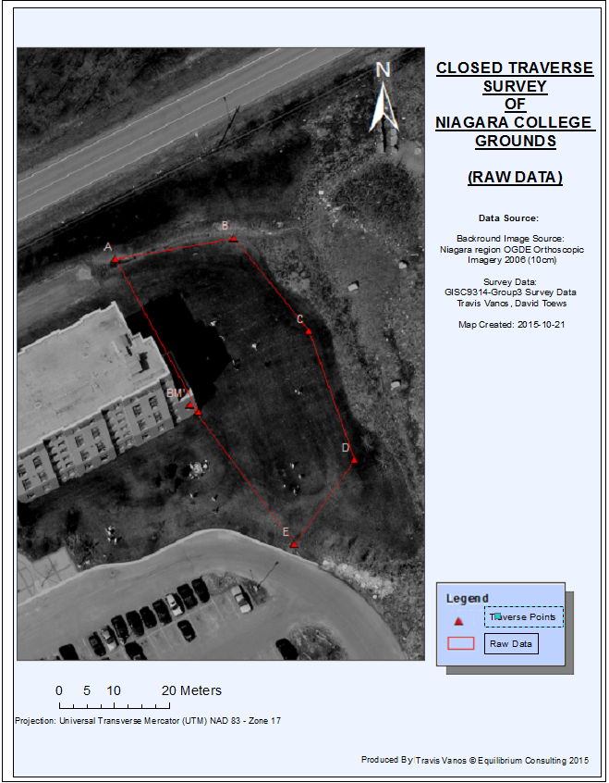

Figure 1 CLOSED TRAVERSE SURVEY of Niagara Grounds (Raw Data) – © Equilibrium Consulting 2015

The raw and collected data has been overlaid atop of panchromatic imagery from 2006 (10cm) by the Municipality of Niagara. The spatial reference system is UTM NAD 83, 17N, estimated to the nearest centimeter from the digital aerial photography.

# 1.2 Raw Collected Pacing Data

## **1.2.1 Member’s Pacing Length**

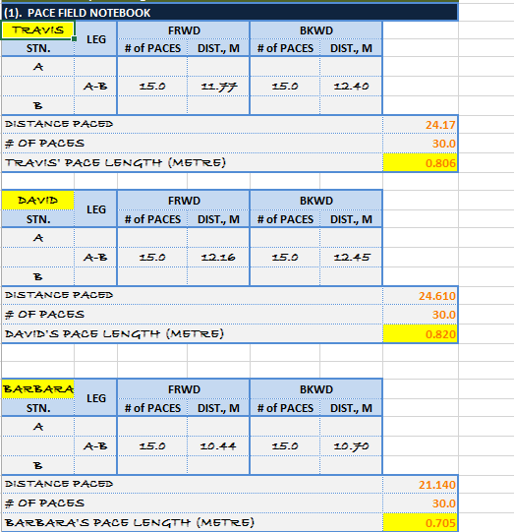  
 In the field the team member’s paces were measured as an average length per pace calculated by measuring the length the fiberglass tape after 15 paces and dividing by 15 to get the average length of each pace. Figure 2 shows the calculated length of the average to be used for the pacing to measure the distance between the two traverse stations.

Figure 2 Member's Pacing Length (avg)

Once the preliminary, average pace length was established each member rotated in pacing forwards and backwards between the two traverse stations after measuring the azimuth.   
  
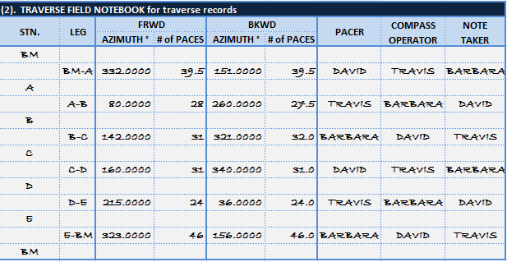

Figure 3 Results from Field Notebooking for Each Member's Pacing

# 1.3 Degree of Error of Interior Angles

## **1.3.1 Raw Data Pacing Lengths**

After the average pacing length has been recorded for each member, pacing could commence on the lengths between the traverse stations. Figure 4 shows the lengths of the traverse leg both forwards and backwards for each member.

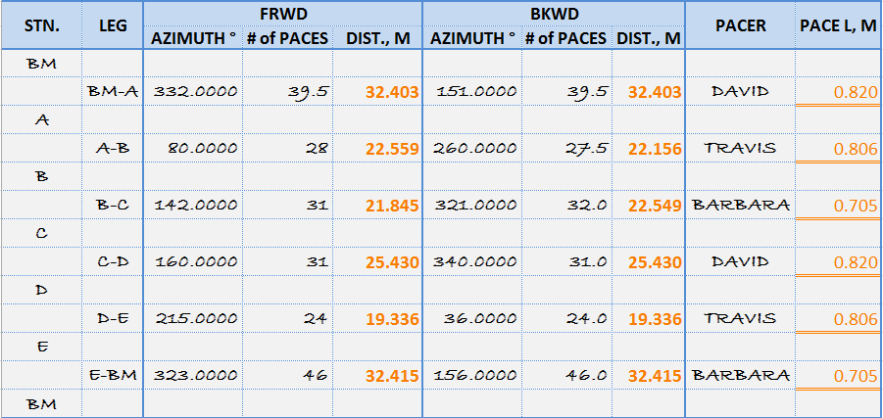

Figure 4 Calculate Average Azimuth and Length of Each Traverse Leg

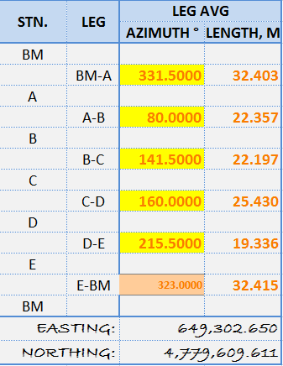Figure 5 shows the leg length in relation to the benchmark to give us out full polygon feature. From traverse station E to the Benchmark (BM), there is a known error in the backward azimuth for this leg, so we have chosen to use only the forward azimuth.

Figure 5 Traverse Leg Length

## **1.3.2 Balanced Interior Angle Corrections**

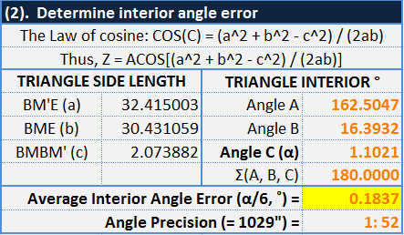

After determining the interior angles of our raw data in relation to our supposed benchmark, using inverse triangle trigonometry of COS (ACOS[(a2 + b2 – c2) / (2ac)] ), we can then determine the margin of error “**C” (α).** Distributing the margin of error to the 6 angles of the polygon yields the angle error as 0.1837 ˚ to correct the traverse as shown in *Figure 7*.

Figure 6 Degree of Interior Angle Error

## **1.3.3 Angle and Azimuth Corrections**

|  |  |
| --- | --- |
| Figure 7 Correct Interior Angles | Figure 8 Corrected Azimuths |

## **1.3.4 Corrected Bearings**

The correct bearing can now be calculated with the new azimuth degree.

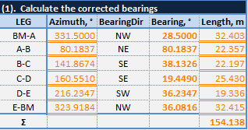

Figure 9 Corrected Bearing (o)

## **1.3.5 Error of Closure and Latitudes/Departures Corrections**

|  |  |
| --- | --- |
| **2) Calculated latitudes and Departures** | Figure 10 Calculated latitudes and Departures |
| **3) Calculated Latitude/Departure/Closure**  **Errors & Precision** ELat & EDep values show too much North & West | Figure 11 Calculated Latitude/Departure/Closure |
| **4) New Latitude and Departure with Corrections** | Figure 12 New Latitude and Departure with Corrections |
| **5) Calculated latitude & departure with corrections** | Figure 13 Calculated latitude & departure with corrections |
| **Final Points B, C, & D**  point A is assumed (651402.111, 4777513.889)    Figure 14 Calculated Coordinates of Points B, C, & D | |

# 1.4 Final Coordinates and Plotting

## **1.4.1 Final Coordinates (UTM) (Cartesian)**

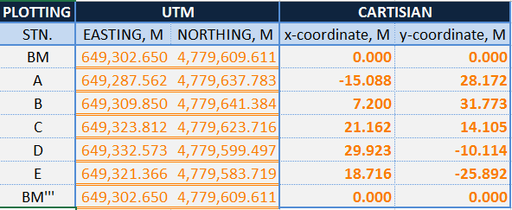

Figure 15 Final Calculated Coordinates for Polygon

**1.4.2 Final Coordinates (UTM) (Cartesian)**

|  |
| --- |
| Figure 16 |

|  |
| --- |
| Figure 17 |

|  |
| --- |
| Figure 18 |

|  |
| --- |
| Figure 19 |
| Figure 20 |

# 1.4.2 Final Corrected Data and Plot

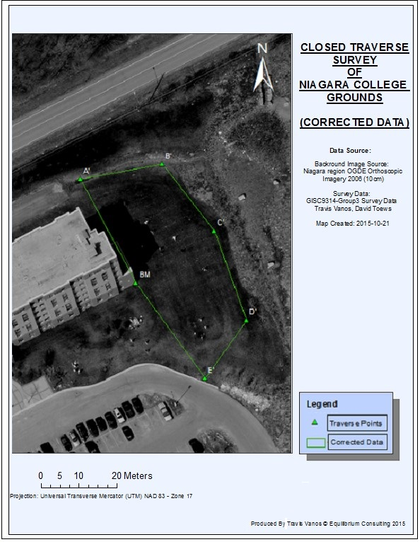

Figure 21CLOSED TRAVERSE SURVEY OF NIAGARA COLLEGE (CORRECTED DATA)